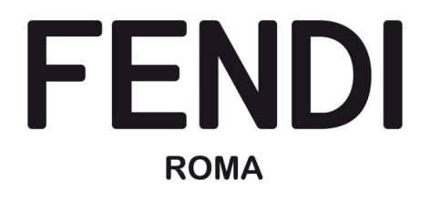

INTERNSHIP within the Collection Merchandising Man LG, Accessories & Shoes Team
The position is based in Rome. As part of the Collection Merchandising Man LG, Accessories & Shoes Team, the intern will support the Manager in the analysis of Luxury Man Market in Middle East. The intern will support building up innovative and successful product, marketing stories and service strategies, to deploy performing products and engaged consumers.
Training Path
The intern will be focused on a new project and the resource will be involved in the following activities:
- Collaborate with the team to identify commercial opportunities on Man LG, Accessories & Shoes Business with a deeper focus on Middle East.
- Liaise with the team in structuring the competitors and market trend analysis to be presented to the studio.
- Cooperate with the team to build the new product marketing tool for the sales campaign.
- Support the team in daily activities from sales analysis to sample management.
- Perform basic retail merchandising tasks and use retail merchandising tools to analyse market specifics.

Profile
- Strong passion for the fashion and luxury industry and knowledge of the new trends with a focus on Middle Eastern markets;
- High proficiency in Excel and Power Point;
- Accuracy and attention to details needed;
- Proactive, creative and self-motivated;
- Strong team player, adaptable and flexible to changes;
- Fluency in English and Italian, and basic knowledge of Arabic.

I CV DEVONO ESSERE INVIATI ALLA DELEGATA DEL RETTORE PER GLI STAGE E I TIROCINI PROF.SSA CHIARA GHIDINI ALL’INDIRIZZO MAIL: cghidini@unior.it

